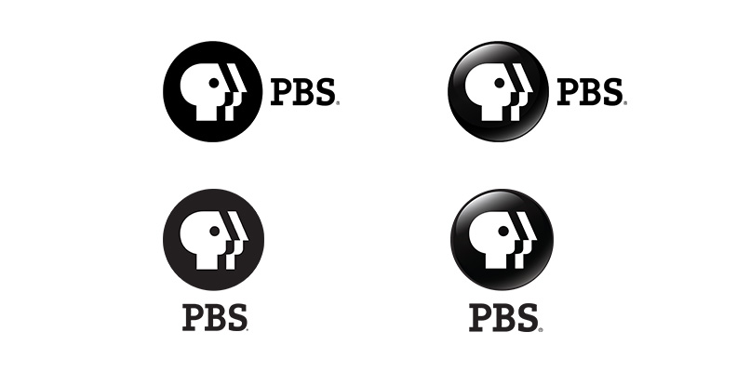

# Public Media Part 1 - Introduction version RC-5

This Enterprise Metadata Model (EMM) is the basis for how commonly interchanged metadata is structured and validated in Public Broadcasting. The EMM uses the Entertainment Identifier Registry as its standard. The EMM builds its schema upon the experience of MovieLabs and Gracenote, respectively. The purpose of the EMM is to improve interoperability for Public Media content. The current version is 2.1﻿﻿. Release Candidate #5﻿ is pending.

Released date: pending  
Document URL: pending

# Introduction

The Public Media Enterprise Metadata Application Profile (MAP) is a metadata schema to improve interoperability across Public Media show products.

This MAP supports the foundational metadata necessary to locate Public Media show products while:

* Browsing a Member Station website
* Identifying show files
* A viewer browses OTT listings
* A viewer browses cable MSO listings
* Planning a program lineup
* Locating a show in traffic software
* A Viewer Services representative seeks to identify a show for a viewer

The MAP does not support specific refinements any one initiative or project. The creation of secondary application profiles is encouraged to extend this MAP for any one specific need.

## Mission

To define and adopt conventions that facilitate Public Media Stations and Distributors to identify content, exchange rich business data about the content, and communicate schedule data.

## Goals

* Promote the use of a common language across Public Media with an Enterprise Metadata Model.
* Ensure the Model aligns to widely accepted industry metadata standards such as EIDR (Entertainment Identifier Registry) and Gracenote.
* Improve interoperability across software applications – such as sIX – by ensuring the Model is machine-readable.

## Background

The emergence of digital has transformed every aspect of every industry. Most notably, everything we touch today turns to data – metadata. Even within the Media Supply Chain from content creation and post-production to distribution and consumption, metadata drives operational efficiency. As the volume and velocity of metadata increases, the variety is unmanageable. A “Master Metadata Application Profile” (MAP) is the answer for enterprises that need a source of truth among “silos” of data.

A Master MAP provides organizations with “common language” to improve interoperability.

ABI Research published the study “TV AND MOVIE METADATA AND CONTENT DISCOVERY FOR PAY TV AND OTT”.

Historically, metadata generation has been a professional services market in which the broadcaster or cable programmer pays a metadata company to author metadata based on their programming.

Internationalization of content…[and] significant changes in the distribution chain of content, in which the same content is syndicated across more services over its lifecycle, coupled with large catalogs of content that attract significant amounts of attention, has meant that the commonality of metadata requirements within larger markets is increasing.

Online services have brought much richer visual user interfaces (UIs) to the consumer’s screens. [This has prompted] many video services today [to rely] on multiple sources of metadata.

## Purpose

Public Broadcasting Service (PBS) acts as the main distributor of content on behalf of the Corporation of Public Broadcasting. To improve interoperability across Public Broadcasting and improve accessibility to our content, this document serves as a Public Media Enterprise Metadata Application Profile (MAP).

When enterprises embark to standardize a MAP, the International Standards Organization (ISO) advises adoption of existing standards and schema to improve interoperability and to reduce unnecessary variation across an industry.

* **A Data Model Standard**. An abstract illustration of how elements of data are organized and standardizes how they relate to one another; and,
* **A Schema(s).** A framework that documents each field’s obligations, constraints, taxonomies (controlled vocabulary) and relationships.

## Selected Metadata Standard and Schemas

**The Public Media MAP adopted the Entertainment Identifier Registry (EIDR) data model standard.**

EIDR provides a two-fold benefit:

* EIDR provides a database of movie, TV, and supplemental open to all metadata contributors (eg, cable MSOs, Satellite Providers, OTT distributors, etc).
* EIDR employs a de-duplication service so as to align all metadata about a content item to a single unique identifier – the EIDR ID – similar to a book’s ISBN number. The EIDR ID is recognized across the entertainment industry.

There is no one industry schema; there are the most preferred schemas – each have a distinct focus. The Public Media MAP aligns to the following schemas, listed in order of rank:

* **MovieLabs Common Metadata Specification**  
  MovieLabs is a Digital Distribution Framework that defines standards for online distribution, automation of digital workflows and supply chain efficiency to improve consumer experiences.
* **CableLabs Content Specification**  
  CableLabs works with academia, government, private healthcare, and entertainment seeking grow community and global connections. Their Content Specification represents information pertinent to the distribution, presentation and consumption of video-on-demand (VOD) content.
* **Gracenote, powered by Nielsen**Gracenote controlled vocabularies and their TMS IDs (formerly Tribune Media) are deeply entrenched within some of the largest audio and video services – both online and traditional cable services.

## Namespaces

Namespaces define a logical reference that maps back to a schema’s source. Public Media MAP references the aforementioned schemas in its framework. In order to claim compliance with this specification, it is necessary to conform to the following standards and other works as indicated, in addition to the other requirements of this specification. Notwithstanding, intellectual property rights may be required to use or implement such normative references.

|  |  |  |
| --- | --- | --- |
| Schema | Namespace | |
| Entertainment Registry Identifier | [eidr] | http://www.eidr.org/schema/2.0 |
|  |  | http://eidr.org/documents/EIDR_2.0_Data_Fields.pdf |
| MovieLabs Common Metadata2.5 | [md] | http://movielabs.com/md/md/ |
| MovieLabs Media Manifest 1.6 | [mmm] | http://movielabs.com/md/manifest/ |
| CableLabs Content 3.0 | [adi] | https://apps.cablelabs.com/specification/?category=METADATA |
| Gracenote/TMS Relay 0.5.7 | [tms] |  |
| Public Media Common Metadata 3.0 | [pm] |  |

## Taxonomies and Data Formats

One a metadata field is defined, a taxonomy (controlled vocabulary) is used to establish a shared categorization or classification system. In certain instances, an enterprise may have its own vocabularies. To avoid unnecessary variations, this MAP references the following standards.

|  |  |  |
| --- | --- | --- |
| Taxonomy/Format | Code | |
| Date and Time Format | ISO8601-2004 | <http://www.iso.org/iso/home/standards/iso8601.htm> |
| Country Codes | ISO3166-1 | <http://www.iso.org/iso/home/store/catalogue_tc/catalogue_detail.htm?csnumber=63545> |
|  | ISO3166-2 | http://www.iso.org/iso/home/store/catalogue_tc/catalogue_detail.htm?csnumber=63546 |
| Language Codes | ISO 639 | <https://www.iso.org/iso-639-language-codes.html> |

# Public Media MAP Domain Model, v3.0

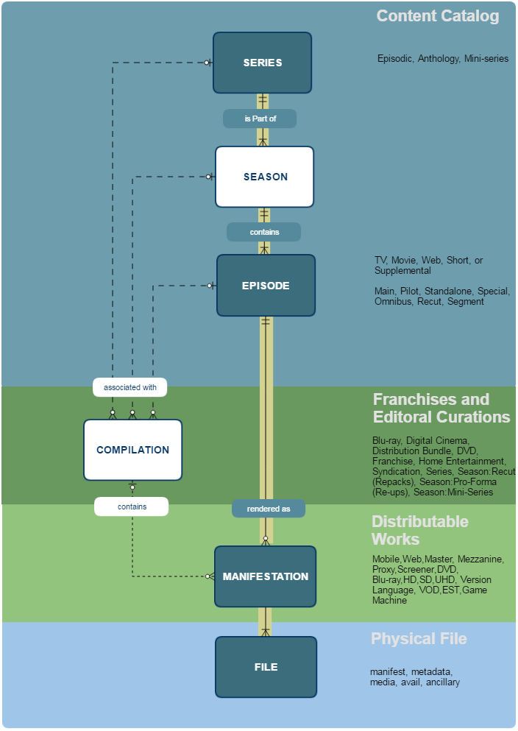

**Domain Model Legend**

|  |  |  |  |  |  |  |  |
| --- | --- | --- | --- | --- | --- | --- | --- |
| -------- | Possible Relationships |  | Core Relationships |  | Core Entity |  | Supplemental Entity |